Образовательный минимум по английскому языку,
1 триместр, 2021-2022 уч.года, 10 (профиль) класс
1. Чтение вслух.
Reading
Imagine that you are preparing a project with your friend. You have found some interesting material for the presentation and you want to read this text to your friend. You have 1.5 minutes to read the text silently, then be ready to read it out aloud. You will not have more than 1.5 minutes to read it.
The first maps were drawn by explorers to help them find their way home and show people where they had been. The maps showed the shape of the land, distances between places and special features such as caves and old trees. Nowadays, maps show the towns and villages, and the roads, railways, rivers and mountains. Symbols are used to show all the different things on a map and there is a key to explain what the symbols stand for.
Over the centuries, people explored most of the Earth and put together the map of the world we use today. Maps of the world or large areas are often either “political” or “physical”. The political map shows territorial borders. The purpose of the physical map is to show features of geography such as mountains, soil type or land use including roads, railroads and buildings.

2.Задайте вопросы по рекламной картинке.
Study the advertisement.
Make your life easier with our new kitchen unit !

You are considering buying the appliance and now you’d like to get more information. In 1.5 minutes you are to ask five direct questions to find out about the following:
1) price
2) if one can buy it online
3) number of functions
4) guarantee period
5) recipe book to go with the unit

ВАРИАНТ ОТВЕТА :
1) price
1. How much does the unit cost?
2) if one can buy it online
2. Can I buy it on-line?
3) number of functions
3. How many functions does it have?
4) guarantee period
4. What is the guarantee period?
5) recipe book to go with the unit
5. Does a recipe book go with the unit?
3.Диалогическая речь
You are going to give an interview. You have to answer five questions.
Give full answers to the questions (2–3 sentences).
Remember that you have 40 seconds to answer each question.
Interviewer: Hello everybody! It’s Teenagers Round the World Channel. Our guest today is a teenager from Russia and we are going to discuss summer holidays. We’d like to know our guest’s point of view on this issue. Please answer five questions. So, let’s get started.
Interviewer: What part of Russia do you live in? What’s the weather like in summer there?
Student: I live in the north-west of Russia. This is Leningrad region. The weather is normally warm in summer. It often rains a lot.
Interviewer: What else would you like our listeners to know about your region?
Student: Leningrad region is an industrial area with lots of big plants and factories. At the same time, it is a culturally developed region. There are many theatres and museums, educational and research institutions here.
Interviewer: What can you tell us about your family?
Student: My family is not very big. It consists of four persons: my mother, my father, my elder brother and me. We get along well with each other.
Interviewer: How did you use to spend your summer holidays when you were seven?
Student: When I was seven, my family and I used to go to the mountains and forests for active holidays. We lived in tents, went river rafting. We were really into extreme things!
Interviewer: How would you like to spend your summer holidays in 10 years?
Student: I think nothing will drastically change in the way I spend my summer holidays in 10 years. I will stick to active holidays, and probably, I will add some other forms of activities such as parachuting or base jumping.
Interviewer: Thank you very much for your interview.
4.Монологическая речь
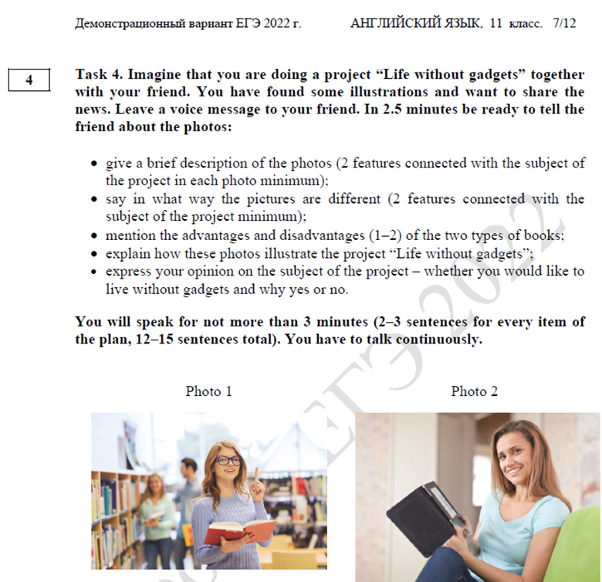
Hi there! Have you received the pictures I’ve sent you by e-mail? I suppose they are perfect for our project “Life without gadgets”.
- In pic 1 there is my mum in her student years. It’s obvious 1) there WERE NO gadgets at that time. However, judging by the number of people in the library, 2) reading was quite popular in those days. As for pic 2, there is my cousin Mary 1) who can’t imagine her life WITHOUT gadgets as she 2) belongs to a digital-savvy generation.
- No doubt the photos are different. Pic 1 illustrates a gadget-free environment where readers had to use traditional paper books. Concerning pic 2, my cousin can read a book at home as she has got an e-book.
- As for pros and cons, I believe the only advantage of a paper book is that you can leave some remarks while reading. Its disadvantage is a necessity to go to the library every time you need it. As for the advantage of e-readers, it’s their ability to store as many books as you need. However, they can crash suddenly when you forget to charge them in time.
- I’m sure these photos illustrate our project perfectly. On the one hand, pic.1 proves that life without gadgets can be quite full and active. My mum thinks so. On the other hand, pic.2 shows that life WITHOUT gadgets is next to impossible for generation Z.
- As I belong to a younger generation, I would like to live in a technological society and use modern gadgets as they make our life much easier and more comfortable.

Please let me know whether you agree on my choice of photos.

5. Грамматика
