Образовательный минимум по английскому языку,
2триместр, 2020-2021 уч.года, 10 (профиль) класс

1. Чтение вслух
Reading
Imagine that you are preparing a project with your friend. You have found some interesting material for the presentation and you want to read this text to your friend. You have 1.5 minutes to read the text silently, then be ready to read it out aloud. You will not have more than 1.5 minutes to read it.
Geography is the study of the Earth and its features, its inhabitants, and its phenomena. The word geography comes from Greek. It means “to write and draw about the Earth”. Geography studies continents, seas, rivers and mountains. It deals with all the people and animals that live on the Earth. It is interested in the things that happen on the Earth like tides, winds, and earthquakes. A person who is an expert in geography is a geographer. A geographer tries to understand the world and the things that are in it, how they started and how they have changed. Geographers need to know a lot about maps because maps are very important for understanding geography.
Geography is divided into two main parts called physical geography and human geography. Physical geography studies the natural environment and human geography studies the human environment. Human geography studies include things such as the population in a country, a country’s economy and so on.

2.Задайте вопросы по рекламной картинке.

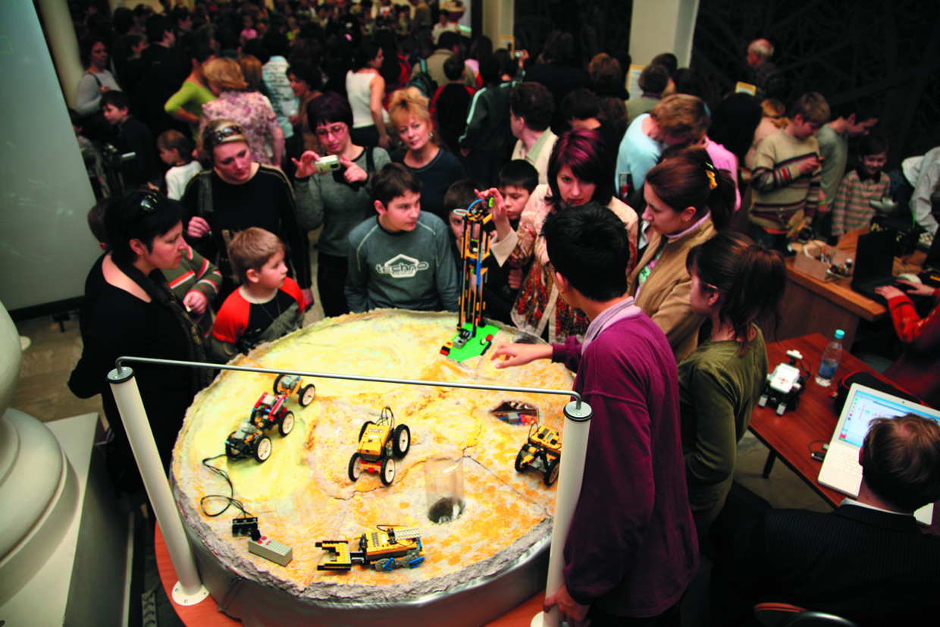

Study the advertisement.You are considering visiting the exhibition and now you’d like to get more information. In 1.5 minutes you are to ask five direct questions to find out about the following:
- opening hours
- number of exhibits
- if one can take photos
- admission fee
- group discounts
You have 20 seconds to ask each question.
3. Монологическая речь
Study the two photographs. In 1.5 minutes be ready to compare and contrast the photographs:
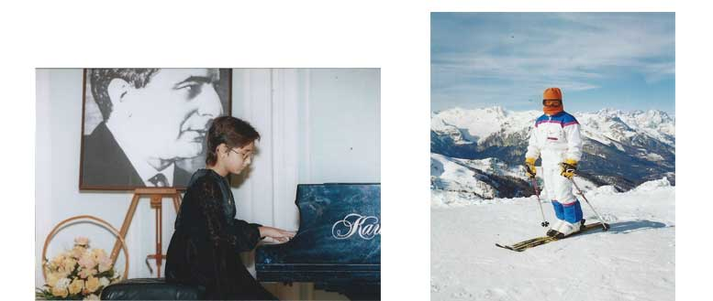

- give a brief description of the photos (action, location)
- say what the pictures have in common
- say in what way the pictures are different
- say which of the professions presented in the pictures you’d prefer
- explain why
You will speak for not more than 2 minutes (12-15 sentences). You have to talk continuously.

4. Грамматика
Как и во всех языках в английском существует будущее время ( Future Tense).
Будущее время делится на несколько видов, если быть точным на четыре:
1. Future Simple Tense – простое будущее время,
2. Future Continuous Tense – продолжительное будущее время,
3. Future Perfect Tense — будущее завершённое время,
4. Future Perfect Continuous – будущее совершенное продолженное время.
