Образовательный минимум по английскому языку,
1 триместр, 2020-2021 уч.года, 10 (профиль) класс
1. Монологическая речь
These are photos from your photo album. Choose one photo to describe to your friend.

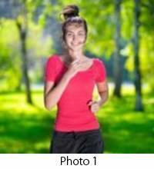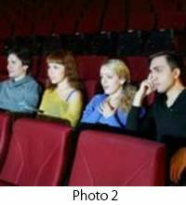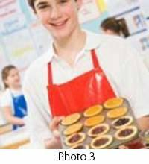

You will have to start speaking in 1.5 minutes and will speak for not more than 2 minutes (12–15 sentences). In your talk remember to speak about:

● where and when the photo was taken
● what/who is in the photo
● what is happening
● why you keep the photo in your album
● why you decided to show the picture to your friend

You have to talk continuously, starting with: “I’ve chosen photo number …”
ВАРИАНТ ОТВЕТА:
“I’ve chosen photo number one”
ВВЕДЕНИЕ:
Taking photos is my hobby. If I have an opportunity to take a good picture I never miss it. I have a picture to show you.
● where and when the photo was taken
This photo was taken a few years ago in a park not so far from my house.
● what / who is in the photo
In the photo you can see my sister Liza. She lives in St. Petersburg. Whenever she comes to Moscow she always stays at our flat and we do things together.
● what is happening
Liza is jogging in the park. Unlike me, she does it every day no matter how bad the weather might be. Fortunately, the weather was perfect that day and we enjoyed jogging together.
● why you keep the photo in your album
I keep this photo in my album because she looks really happy and cute here. I like to see her happy.
● why you decided to show the picture to your friend
You know, Liza is an artist. I've decided to show you this picture because you once told me that you would like to learn to paint. She will be here next week so I think you could meet her and take a few lessons.
ЗАКЛЮЧЕНИЕ:
Now you know what my friend looks like. Hope you will enjoy talking to her.
That’s all I wanted to say.
Вот что получилось:
I’ve chosen photo number one. Taking photos is my hobby. If I have an opportunity to take a good picture I never miss it. I have a picture to show you.
This photo was taken a few years ago in a park not so far from my house.
In the photo you can see my sister Liza. She lives in St. Petersburg. Whenever she comes to Moscow she always stays at our flat and we do things together.
Liza is jogging in the park. Unlike me, she does it every day no matter how bad the weather might be. Fortunately, the weather was perfect that day and we enjoyed jogging together.
I keep this photo in my album because she looks really happy and cute here. I like to see her happy.
You know, Liza is an artist. I've decided to show you this picture because you once told me that you would like to learn to paint. She will be here next week so I think you could meet her and take a few lessons.
Now you know what my friend looks like. Hope you will enjoy talking to her.
That’s all I wanted to say.

2.Задайте вопросы по рекламной картинке.
Study the advertisement.
Make your life easier with our new kitchen unit !

You are considering buying the appliance and now you’d like to get more information. In 1.5 minutes you are to ask five direct questions to find out about the following:
1) price
2) if one can buy it online
3) number of functions
4) guarantee period
5) recipe book to go with the unit

ВАРИАНТ ОТВЕТА :
1) price
1. How much does the unit cost?
2) if one can buy it online
2. Can I buy it on-line?
3) number of functions
3. How many functions does it have?
4) guarantee period
4. What is the guarantee period?
5) recipe book to go with the unit
5. Does a recipe book go with the unit?
3. Чтение вслух.
Reading
Imagine that you are preparing a project with your friend. You have found some interesting material for the presentation and you want to read this text to your friend. You have 1.5 minutes to read the text silently, then be ready to read it out aloud. You will not have more than 1.5 minutes to read it.
The first maps were drawn by explorers to help them find their way home and show people where they had been. The maps showed the shape of the land, distances between places and special features such as caves and old trees. Nowadays, maps show the towns and villages, and the roads, railways, rivers and mountains. Symbols are used to show all the different things on a map and there is a key to explain what the symbols stand for.
Over the centuries, people explored most of the Earth and put together the map of the world we use today. Maps of the world or large areas are often either “political” or “physical”. The political map shows territorial borders. The purpose of the physical map is to show features of geography such as mountains, soil type or land use including roads, railroads and buildings.
4. Грамматика
